**Fixed-Point Data Type Demonstration Instructions**

1. Open <Exercises>\LabVIEW FPGA\Demonstrations\Fixed-Point Data Type\Fixed-Point Data Type.lvproj.
2. From the Project Explorer, open Fixed-Point Configuration.vi.
3. Run the VI.  
   This VI allows you to drag the decimal point to different positions and click each bit to set its value 0 or 1. In this VI, the Word Length will always be 8, so there are always only 8 bits you can set.
4. Demonstrate <+,8,8> fixed-point configuration. This is the easiest configuration to explain.
   1. Verify that the decimal point is located as shown in the following figure.  
      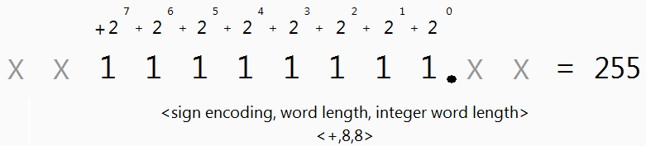
   2. Note that the fixed-point configuration is unsigned, has a Word Length of 8, and has an Integer Word Length of 8.
   3. Show that the maximum is equal to 255 (when all bits are set to 1) and the minimum is 0 (when all bits are set to 0).  
      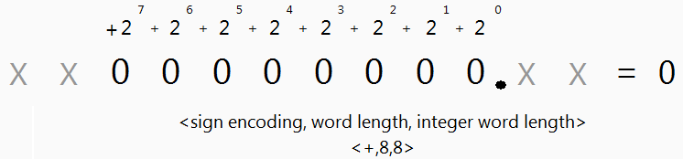
   4. Show that the delta is equal to 1 (when the least significant bit is set to 1 and the rest of the bits are set to 0).  
      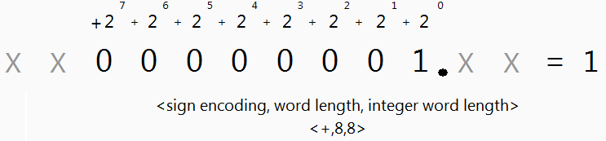
5. Demonstrate <+,8,7> fixed-point configuration. This shows how Word Length and Integer Word Length can be used to represent fractional numbers.
   1. Verify that the decimal point is located as shown in the following figure.  
      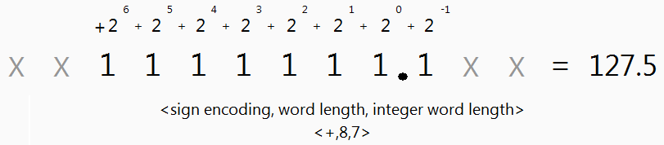
   2. Show that the maximum is 127.5 and the minimum is 0.
   3. Show that the delta is equal to 0.5
6. Demonstrate <+,8,9> fixed-point configuration. This shows how the Integer Word Length can actually be larger than the Word Length.
   1. Verify that the decimal point is located as shown in the following figure.  
      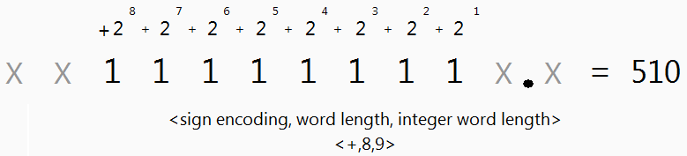
   2. Show that the maximum is 510 and the minimum is 0.
   3. Show that the delta is equal to 2.
7. Demonstrate <+,8,9> fixed-point configuration. This shows how the Integer Word Length can actually be a negative number.
   1. Verify that the decimal point is located as shown in the following figure.  
      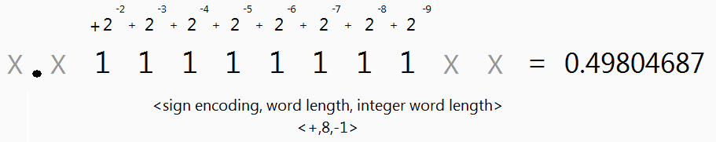
   2. Show that the maximum is 0.49804687 and the minimum is 0.
   3. Show that the delta is equal to 0.001953125.
8. Demonstrate other fixed-point configurations as necessary for understanding.